Jessica Gerschultz

***École de Tunis***

The *École de Tunis* was an elite circle of Tunisian, French, and Italian artists formed in 1948 and credited for pioneering a Tunisian artistic modernism. Both the group’s membership and aesthetic purview evolved over the course of the late nationalist and post-Independence periods. Pierre Boucherle, a French artist born in Tunis, founded the group. With Tunisian independence in 1956 Yahia Turki became its president. Affiliation with the *École de Tunis* was exclusive to elite artists but fluid. Its members included Moses Levy, Nello Levy, Ammar Farhat, Abdelaziz Gorgi, Jellal Ben Abdallah, Safia Farhat, Zoubeïr Turki, Hatem el Mekki, Ali Bellagha, Hédi Turki, and Brahim Dhahak. While the group did not issue mandates it was cohesive in its effort to create an artistic modernism that characterized the Tunisian personality. Thematic content was grounded in research on *tunisianité*, Tunisian cultural patrimony, and emphasised local landscapes and figures, interior scenes, quotidian life, and the nation’s geographic and cultural position in the Mediterranean region. This orientation did not preclude female nudes, sunbathers, and still lifes, but rather stressed historic transcultural linkages, cross-influences, and Tunisian “openness.” The postcolonial *École de Tunis* is associated with the rule of Tunisia’s first president Habib Bourguiba and official state recognition.

Pierre Boucherle, built the group on two previous networks of artists. In 1936 he created the *Groupe des Quatres*, which was composed of Moses Levy, a Tunisian artist of Jewish descent, Jules Lellouche, a French artist born in Monastir, and Antonio Corpora, an Italian artist born in Tunis. After World War II the circle expanded as the *Groupe des Dix* to include Nello Levy, Edgar Naccache, Emmanuel Bocchieri, Yahia Turki, Ammar Farhat, Abdelaziz Gorgi, and Jellal Ben Abdallah. Around 1948 Boucherle renamed the group the *École de Tunis* and became its president. He chose the name to reflect the group’s multiplicity of cultural and religious identities and in homage to the *École de Paris* and Paris-Tunis café culture. Tunisian artists later associated with the *École de Tunis* include Zoubeïr Turki, Hatem el Mekki, Ali Bellagha, Hédi Turki, and Brahim Dhahak. In 1960 Safia Farhat became the only woman to join the group.

In 1950 Boucherle and Ben Abdallah served on a Protectorate committee that oversaw the decoration of buildings under the 1% law. This body established a patronage network between the *École de Tunis*, colonial art institutions, and state infrastructure, and secured more than two decades of commissions for *École de Tunis* artists. It also provided the basis for a postcolonial interrogation of the decorative arts and the role of artist-designer.

With Tunisian independence in 1956 Yahia Turki became president of the *École de Tunis*. The transition from Protectorate to postcolonial governance altered the group’s composition as some artists left for Europe. The transforming political environment also signaled a shift in materials, as artists such as Safia Farhat, Abdelaziz Gorgi, and Ali Bellagha reoriented their scope of production from drawing and painting to the use of materials derived from the local artisanal industry: wool, ceramics, ironwork, wood, and stone. This shift in medium, coupled with an iconographic emphasis on Tunisian cultural patrimony, has led to the frequent characterisation of the *École de Tunis* as “folkloric.” Affiliated artists enjoyed esteemed careers long after the nationalist fervor subsided.

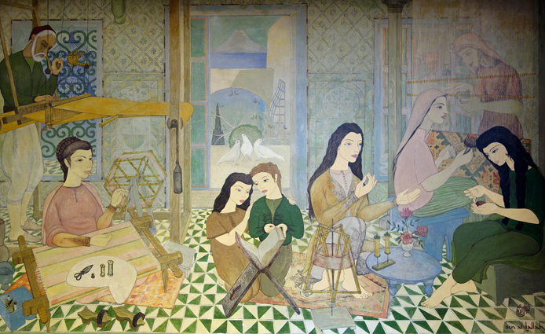

Jellal Ben Abdallah, Untitled, 1953. Mural. Maison de la Tunisie, Cité internationale universitaire de Paris. Image courtesy of the artist. Photograph by Jessica Gerschultz.

**References and further reading**:

(2010) *Paris-Tunis Tunis-Paris: Peintres en Mouvements, 21 avril-20 juin 2010*, Djerba: Dar Cherif/Centre International d’Art et de Culture.

Ben Cheikh, N. (2006) *Peindre à Tunis: Pratique artistique maghrèbine et histoire*, Paris: Harmattan.

Ben Rhomdane, N. et al. (2000) *Anthologie de la peinture en Tunisie 1894-1970*, Tunis: Ministère tunisien de la culture et de la Communauté européenne.

Ben Rhomdane, N. (2002) *Les pionniers de la peinture en Tunisie*, Tunis: Ministère de la Culture.

Boucherle, F. (1997) *Boucherle: Aux Origines de l'École de Tunis*, Tunis: Cérès Editions.

Bouzid, D. (1995) *École de Tunis*, Tunis: Alif- Les Editions de la Méditerranée.

Bouzid, D. (1964) ‘Boucherle de l'École de Tunis’, *Faïza* 39: 20-23+48.

Chelbi, M. (2002) *La Quête de la Tunisianité*, Tunis: Finzi.

Filali, A. (2005) *Safia Farhat: Une Biographie*, Tunis: MIM Editions.

Louati, A. (1997) *L’aventure de l’art moderne en Tunisie*, Tunis: Simpact Editions.